LED Matrix Audio Visualizer

Group Members: Hunter Larson, Andy Liu, Kaitlyn Yau

# **Device Functionality**

We created a 6x6x6 LED cube with the primary function of visualizing audio signals. This will be accomplished by sampling the audio signal from a 3.5mm jack (plugged into a phone or other audio player) with the MSGEQ7, a 7-band graphic equalizer and dividing the output into 36 frequency bands.

Once we’ve computed the frequency bands, we will use shift registers to turn on certain columns in the matrix (each column in the cube shares a common anode) while powering only one layer at a time (each layer shares a common cathode). Repeating this process in rapid succession will allow us to create a persistence of vision effect, thus conveying the magnitude of each frequency band by varying the number of LED’s we turn on in each column

# **Hardware Components**

1. 1x Arduino Nano (already have)
2. 1x USB Wall Adapter & Cable w/ Barrel Jack (already have)
3. 1x (Female) Barrel Connector for Power (already have)
4. 1x Rocker Switch for Power (already have)
5. 2x 3.5mm Audio Jacks (already have)
6. 6x NPN Transistors (Already Have)
7. 1x [Protoboard](https://www.amazon.com/Double-Sided-Protoboard-Prototyping-10X15CM/dp/B07HFFLGFV/ref=sr_1_6?dchild=1&keywords=large+protoboard&qid=1611857863&sr=8-6) ($12.00)
8. 1x [Seven Band Spectrum Analyzer Board](https://www.amazon.com/MSGEQ7-Spectrum-Analyzer-Breakout-Stereo/dp/B08GY46BY8/ref=sr_1_8?dchild=1&keywords=MSGEQ7&qid=1611957261&s=electronics&sr=1-8&th=1) ($20.00)
9. 216x [Diffused, White LED’s](https://www.amazon.com/100pcs-Ultra-Bright-Emitting-Diffused/dp/B01GE5NB5U/ref=sr_1_17?dchild=1&keywords=white+led+3mm&qid=1611958019&sr=8-17) ($19.00)
10. 72x [220-ohm Resistors](https://www.amazon.com/Projects-100EP512220R-220-Resistors-Pack/dp/B0185FID0K/ref=sr_1_3?dchild=1&keywords=220+ohm+resistor&qid=1611958984&sr=8-3) ($7.00)
11. 6x [Shift Registers](https://www.amazon.com/MCIGICM-74HC595-SN74HC595N-Register-registers/dp/B07HFWB9L9/ref=sr_1_2?dchild=1&keywords=shift+registers&qid=1611856770&sr=8-2) ($7.50)
12. 6x [IC Sockets](https://www.amazon.com/Uxcell-a11090300ux0244-2-54mm-Socket-Adaptors/dp/B0079SM1LW/ref=sr_1_5?dchild=1&keywords=16+pin+ic+socket&qid=1611959612&sr=8-5) ($8.00)
13. 3x [Ribbon Cables](https://www.amazon.com/gp/product/B07FKRYJVR/ref=ppx_yo_dt_b_asin_title_o02_s00?ie=UTF8&psc=1) ($9.00)
14. 3x [Connectors For Ribbon Cables](https://www.amazon.com/JZK-crimper-crimping-connectors-assorted/dp/B07PCQ5VMV/ref=sr_1_4?dchild=1&keywords=ribbohttps://www.amazon.com/gp/product/B0834RW6X8/ref=ppx_yo_dt_b_asin_title_o02_s00?ie=UTF8&psc=1)($7.00)

Total: $89.50

# **Design Timeline**

Week 5: Found and ordered the parts needed for our project

Week 6: Began building the cube, managed to solder our 6 layers of LED’s.

Week 7: Came up with potential solutions to attaching our 6 layers of LED’s together (which we were having trouble with at the end of week 6). Began programming.

Week 8: Successfully attached the 6 layers of LED’s together to finish making our cube. Continued programming.

Week 9: Finished programming. Began and finished multiplexer circuit. Began audio circuit

Week 10: Finished audio circuit, attached cube to circuit. Currently debugging.

# **Software Design**

<https://github.com/hslarson/ECE-5-LED-Cube> The README in the github link contains the details of every function we used including the ones in the flowchart below. There, you can also find our completed code.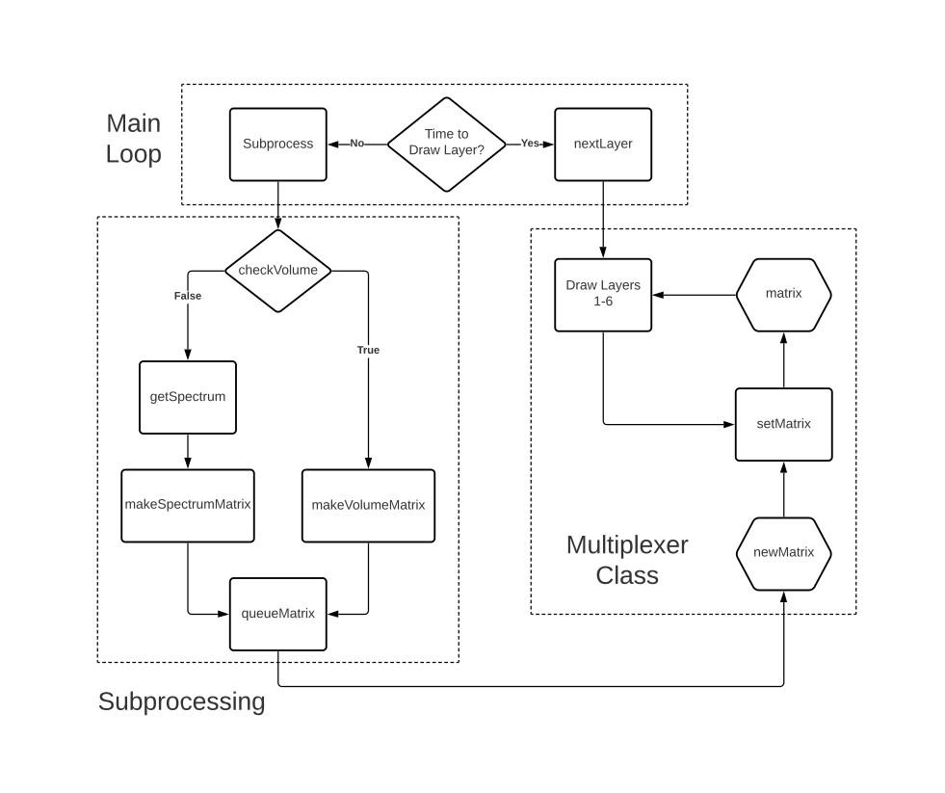

# **Circuit Schematic**

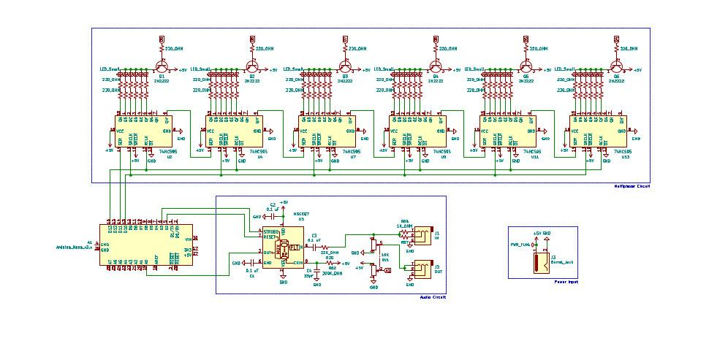

# **Circuit Prototype**

*Cube and Circuit Exterior* :

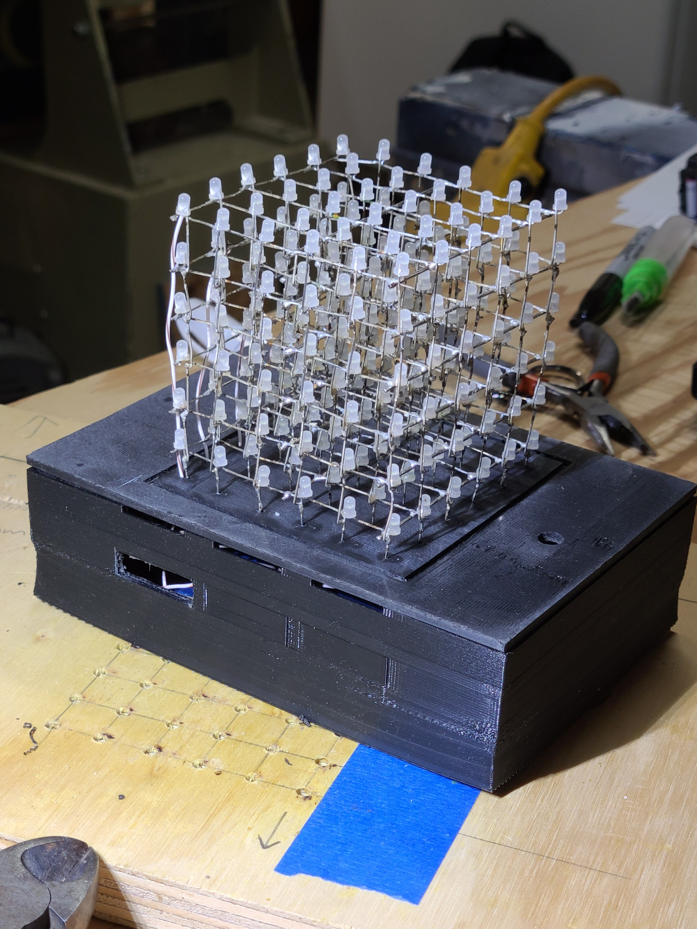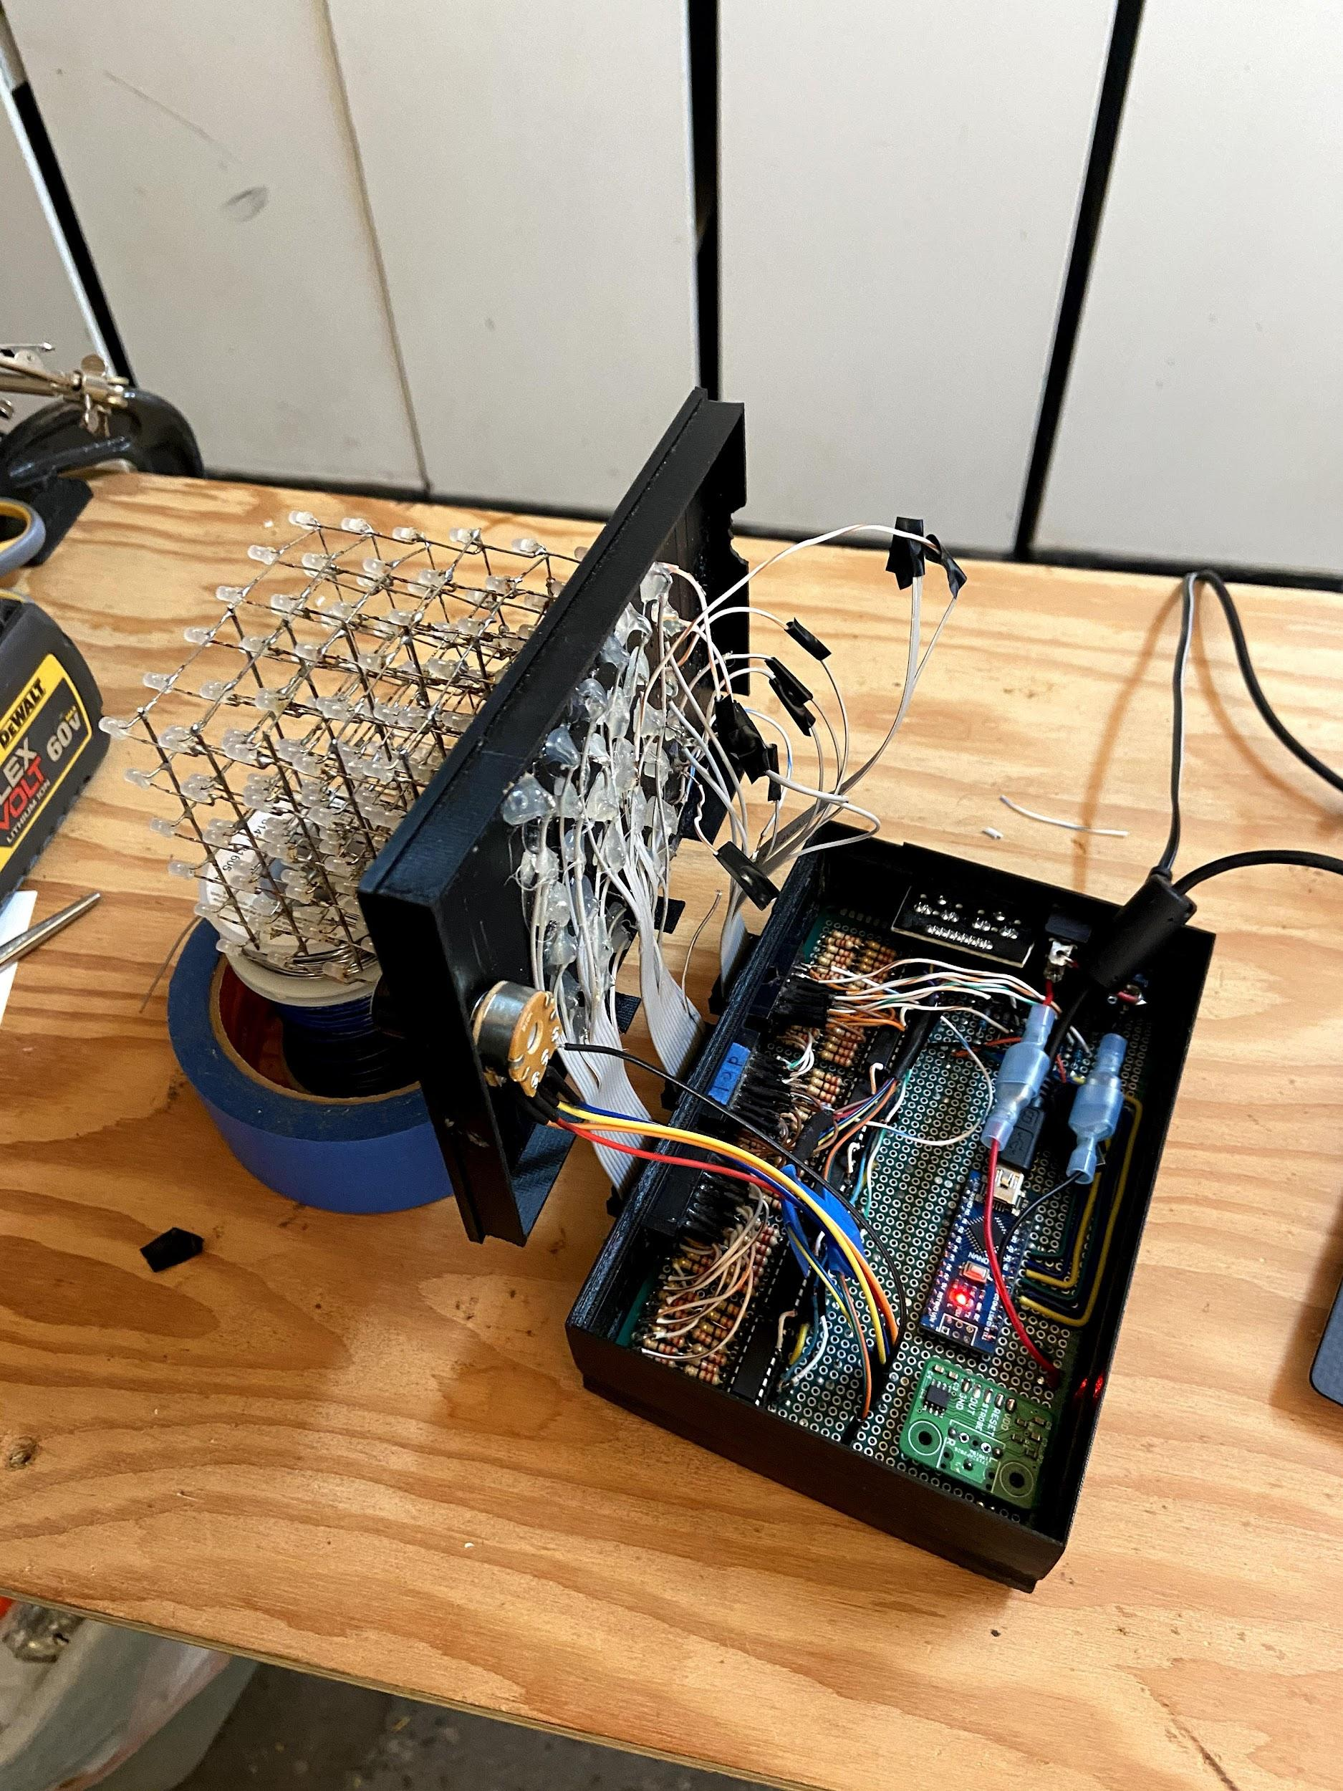

*Circuit Top and Bottom View* :

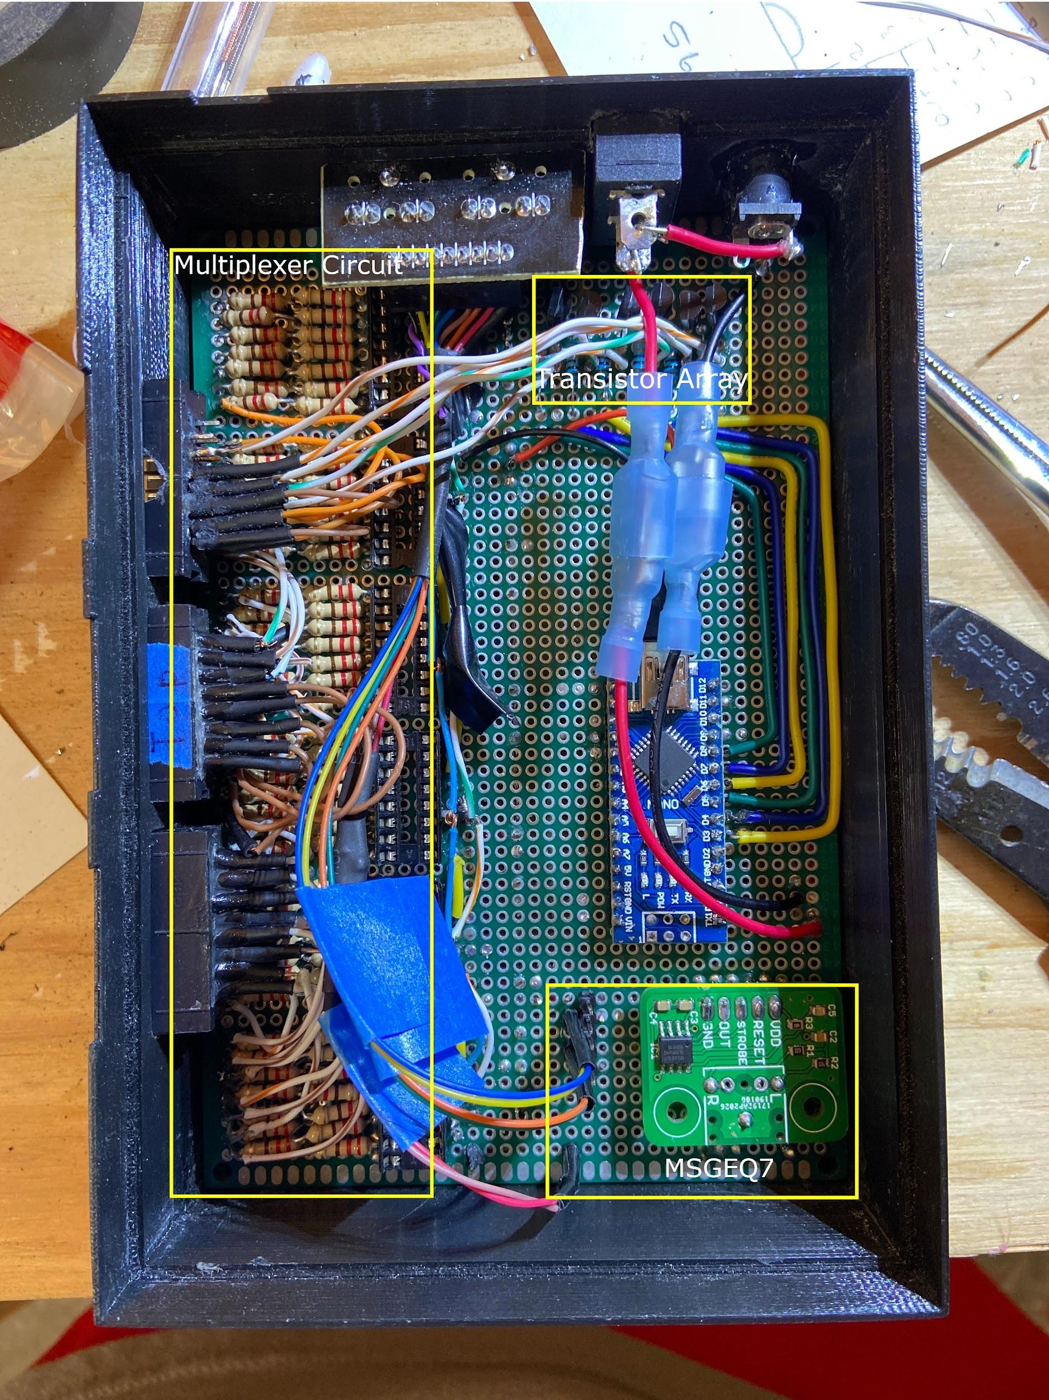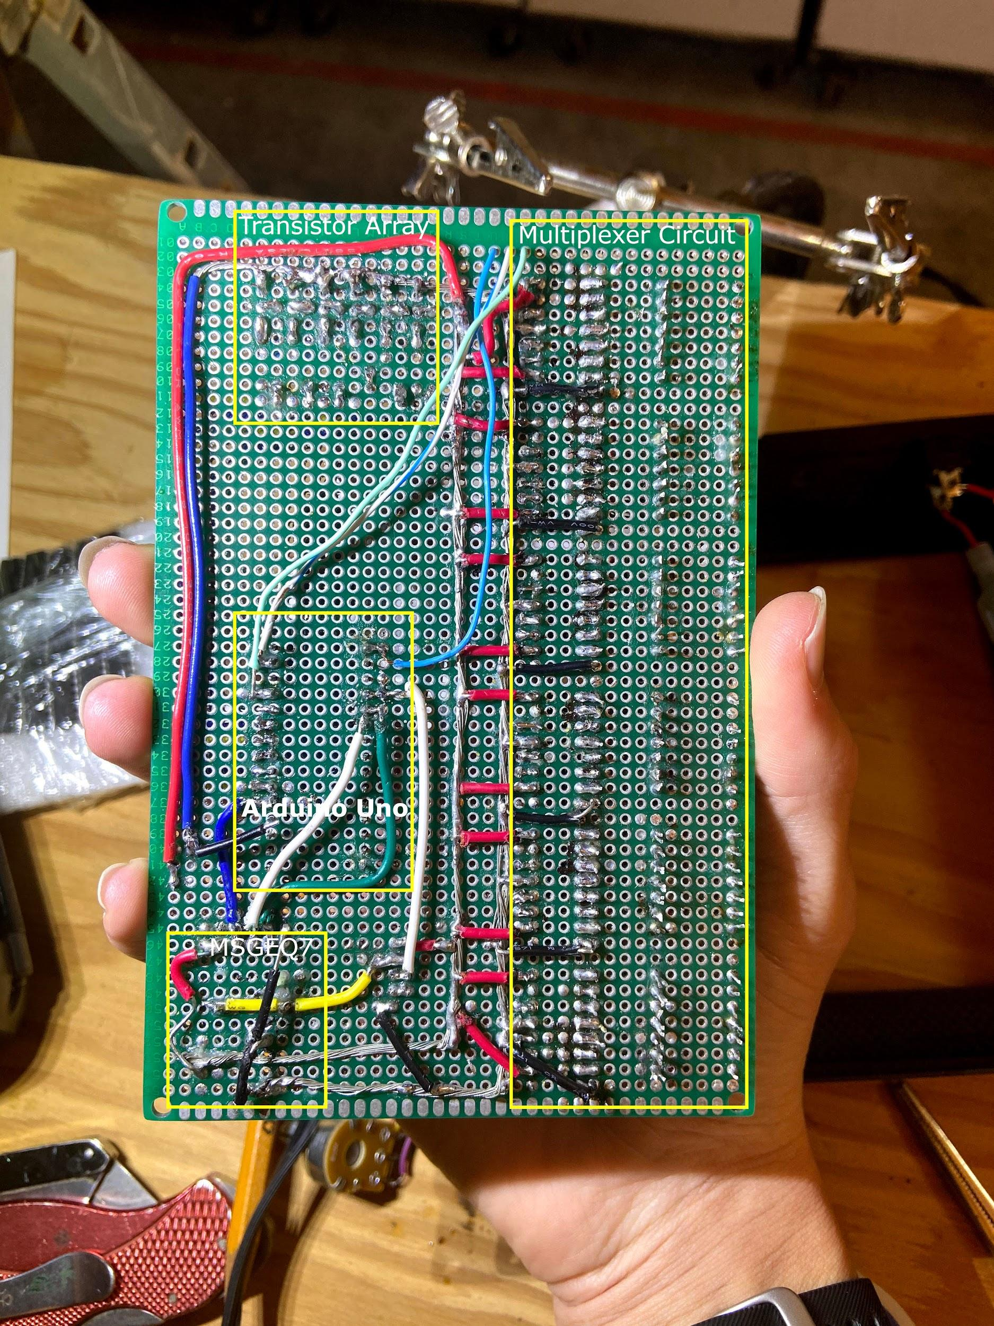

# **Testing**

* Tried to build a MSGEQ7 circuit using loose components, didn’t work
  + Used oscilloscope to determine that both MSGEQ7 chips I had received were defective
* Attempted to find which shift register pins corresponded to which led’s
  + Found that around 4 led’s were disconnected
  + Found that some of the pins of the connectors were loose and therefore not connecting properly
* Fixed the connection issue with superglue, retested bad led’s, 2 remained unpowered
  + Connected some of the unused wires of the ribbon cable to problem led’s
  + Also fixed an issue where one of the cables had snapped
* Noticed the issue with the shift registers not getting data
  + Probed the clock/latch lines and found there was a short, still didn’t work
  + Probed the data line and found no problems
  + Probed clock line and found that nothing was happening
  + Probed the microchip of the Arduino and found that the clock signal was being generated properly
  + Determined the issue to be a broken copper trace running to pin 13 of the Arduino. Modified software to use shiftOut instead of SPI bus
* Had an issue where MSGEQ7 was unable to read data
  + Fixed this issue by plugging headphones into the output jack
  + Not sure why this fixed it, but it seems like the jacks aren’t being grounded correctly
* Had an issue where layer 4 seemed to be off when it shouldn’t be
  + Reordered the pin constants in software so that the pin that had been connected to layer 4 was connected to layer 6 and vice versa
* Found that the box lid wouldn’t close due to stiff ribbon cables
  + Tried to print a spacer, but accidentally made it too tall
  + Didn’t have time to fix it before shooting the video, so I just held the top so it was somewhat level with the base. I will probably reprint the entire base on my own time